Sizwe Majola
programming 2b PROG6212
PROG6212 Part 3:

Programming Part 3: [Application of Part 2 Feedback]

- This is a document to show how the feedback from Part 2 was applied. It will have a screenshot of the feedback, and screenshots of how the feedback was applied as well .

Screenshot of Feedback:

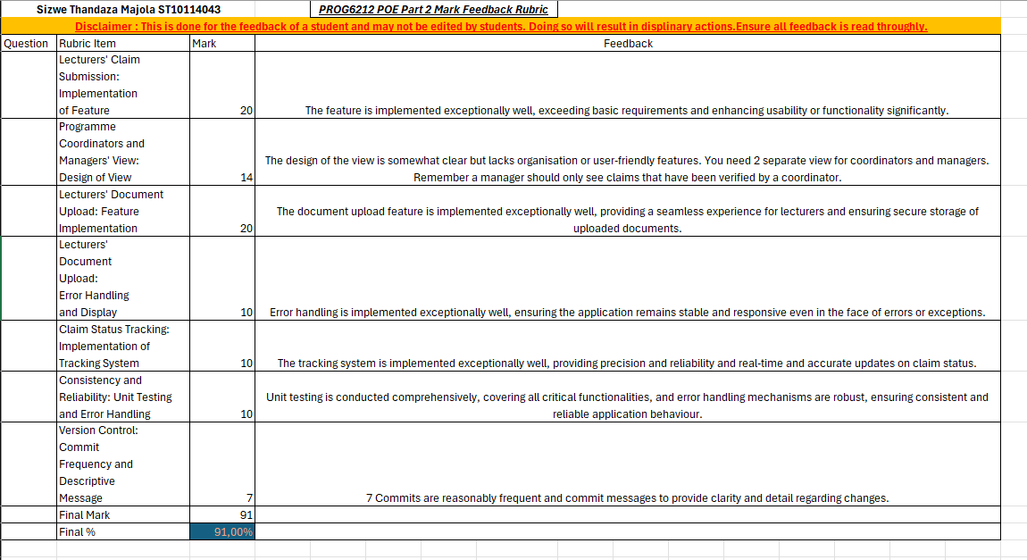

Summary of how feedback was applied:

- 2 Separate views for coordinators and managers were created in part 3

- More than 10 commits were made on git hub for part 3

Manager Dashboard :

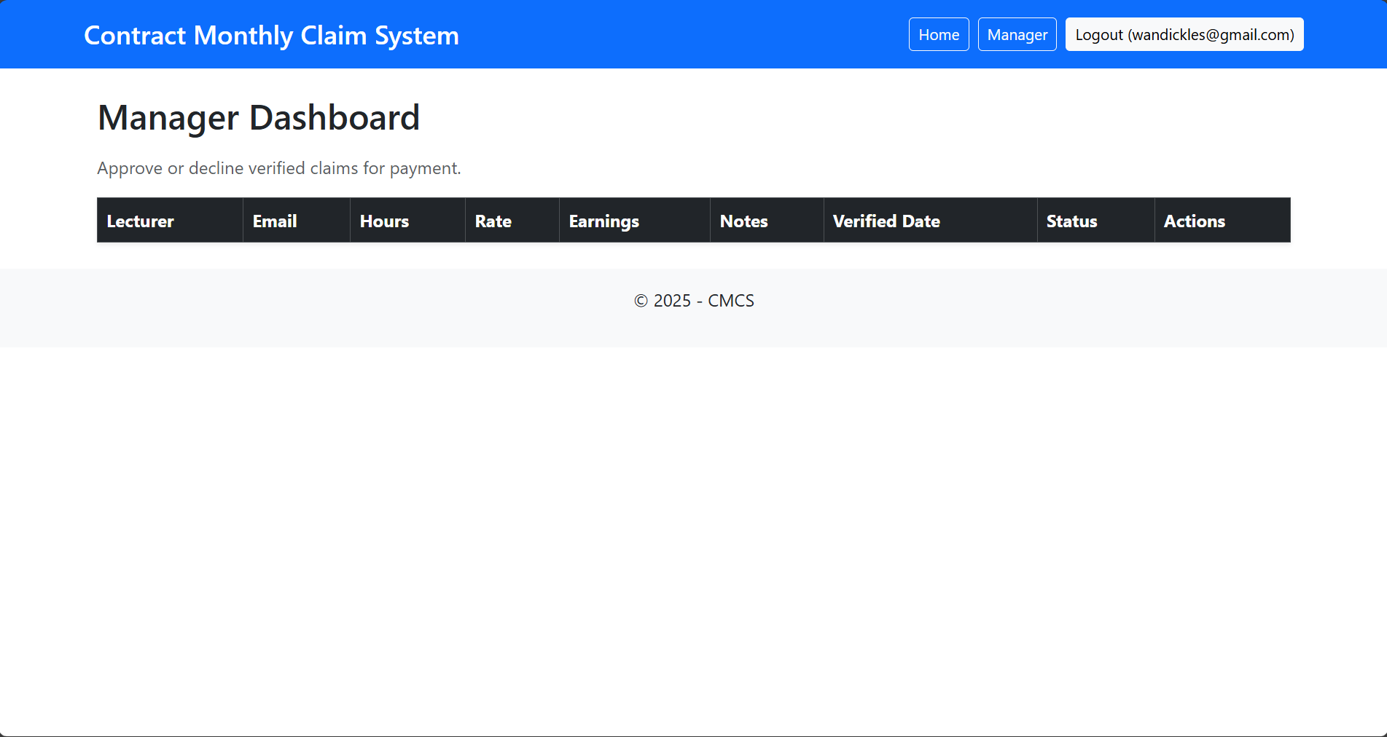

Coordinator Dashboard:

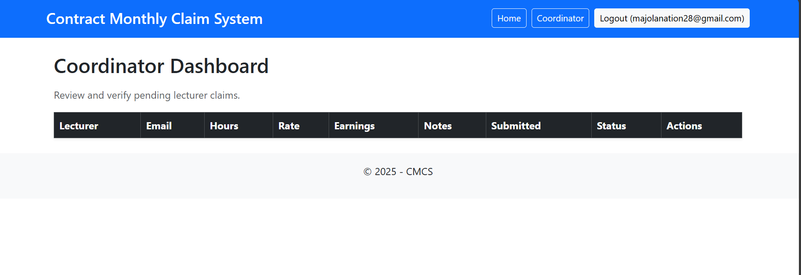

12 Git commits:

